Chariots of Fire  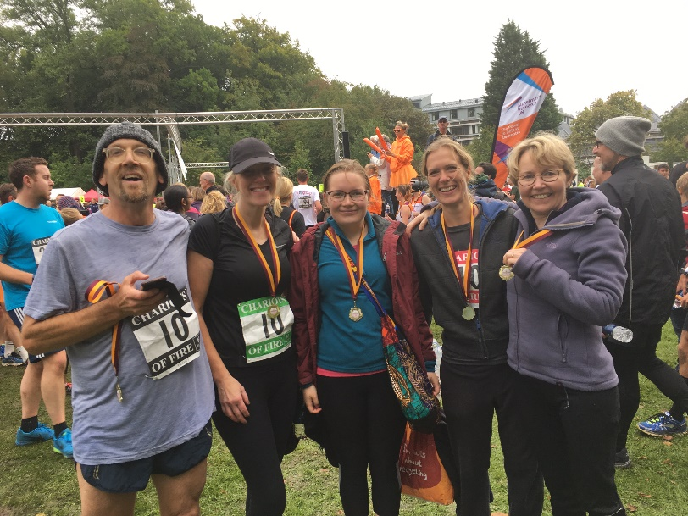  The Huntingdon Road G.P Surgery team, who ran the Chariots of Fire charity relay race on Sunday 17th September.  This year the Chariots of Fire relay race was being held in support of Alzheimer's Research U.K. Our fantastic team ran the 1.6 miles each, completing the course in 1 hour 17mins and 42 seconds, finishing 153rd place out of 333 participating teams. Well done Huntingdon Road!  Booking appointments and ordering prescriptions online  Please consider registering for SystmOnline to allow you to book appointments and order repeat prescriptions online. You can also register to see your medical records, and look up investigation results.  All we need is some photo identification, so that we are sure we are giving access to the right person. It is then very easy to do via our website and access is password protected. Just ask at reception  Mobile Telephones  We are keen to record your mobile telephone number, and seek your consent to receive text messages from the Surgery. We might do this to remind you of an appointment, following a consultation or telephone conversation, or we might want to invite you for a review if it is due. If you are happy please let reception know.  Friends and Family Feedback  We are always keen to hear feedback regarding the care we provide. There are Friends and Family cards in both surgeries for you to say whether you would recommend the surgery to your Friends and Family, and give more specific feedback. They can  then be posted in the boxes provided. If you put your name on the card, we can respond to your comment or suggestion. Alternatively, you can use the e-mail address on the website, although this would not be secure and you should not use this method for your private and confidential information. We are keen to hear from you.  Influenza Vaccines  We are now giving Influenza vaccines again and encourage people eligible to have the vaccine to book an appointment at the surgery. We are keen to give the vaccine at the Surgery so that we have full details in our medical records. Please do book an appointment.  We would particularly recommend you have a vaccine if you have any of the following conditions:  - Chronic Respiratory complaints, including Asthma if you need regular steroid inhalers  - Chronic Liver or Kidney disease  - Heart Disease  - Diabetes  - Chronic Neurological conditions  And if you are:  - Immunosuppressed  - Pregnant  - Over the age of 65 years  - Children aged 2 and 3 years  - A Carer responsible for an Older Person whose welfare may be affected if their Carer falls ill  If you are in one of these groups please book an appointment to have a flu vaccine, unless you have had a serious reaction to a past vaccine, in which case you should first discuss it with your doctor or nurse.  Influenza vaccines protect those patients who may be at greater risk of developing more serious complications. | Confidentiality at the Reception Desk  Protecting patient confidentiality is an important issue we take very seriously. Unfortunately, the reception desk is in the waiting room area and it is difficult to talk to the receptionist without being overheard. So if you are waiting please give the person ahead of you space. If you want to speak to the receptionist confidentially, please just ask and they will arrange a private room.  Alternatively, you could telephone the surgery as the telephone calls are answered away from the reception desk in the back office.  If at any time you do not feel comfortable discussing things with the receptionist just say you would prefer to talk to the doctor or nurse.  Eddington: New District in Cambridge  The new district of Eddington is now open and people are beginning to move in. We are happy to see them at Huntingdon Road Surgery and encourage them to register as soon as possible. It is helpful to register with a GP early so that we can obtain medical records before any specific health need arises. There are plans to open a Health Centre on the Eddington site, but this might be some time in the future, and we are not sure who will be running it. So please do register at Huntingdon Road Surgery in the meantime.  The care and services for people already registered at Huntingdon Road Surgery will not change as we will increase the number of doctors and nurses to help treat the increased number of patients.  Gluten Free Prescriptions  Unfortunately, we have been asked to stop prescribing Gluten Free products for people with Coeliac Disease. The Cambridge and Peterborough Clinical Commissioning Group (CCG) have reviewed this prescribing and have made a decision that this will no longer be funded.  They feel that that these products are now readily available and appropriately labelled in supermarkets for people to buy. This is part of the CCG review of their budget, trying to stay within the budget and to spend it in the most appropriate way.  Patient Group  The practice has a well-established Patient Group – you can read about our activities and/or join on the Huntingdon Road Surgery website. We always welcome new members - and especially new ideas. Contact us with suggestions you would like us to consider via our dedicated email: hrsppg@gmail.com  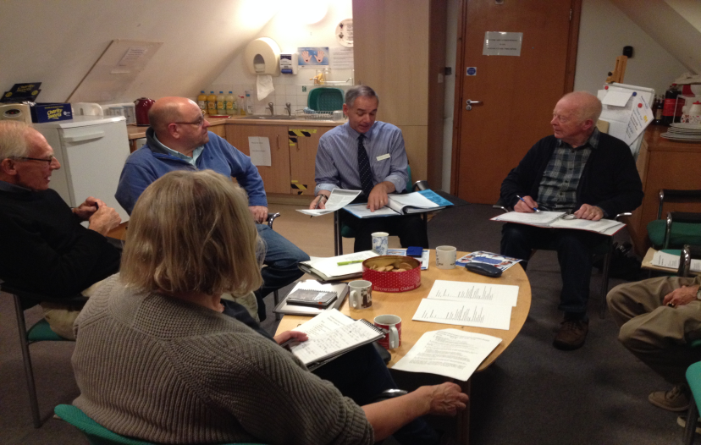  The Annual General Meeting took place at the Huntingdon Road Surgery in late September, when the current committee members were re-elected.  David Faulkner (chair), Robert Sanders, Yvonne Higgons, Jackie Grimshaw, Peter Teich, Dr. Peter Connan (ex-officio) All would be pleased to hear your comments and suggestions as to what you would like from your Patient Group and about how the surgery runs.  Neil Paterson, Business Manager, gave an interesting talk about the Practice Plan for 2017-18, covering both how the surgery plans to deal with major change in the area as well as its plans for improving patients’ experience. These included:  - The impact on the surgery from new housing development at Eddington, and from the new college accommodation block replacing Mount Pleasant House (next-door to the surgery in Huntingdon Road)  - Plans for improving the telephone system that would manage peak morning calls from patients.  - Plans for TV monitors in waiting rooms that will provide information about upcoming appointments on the day as well as more general information about the surgery, such as the availability of influenza vaccines.

