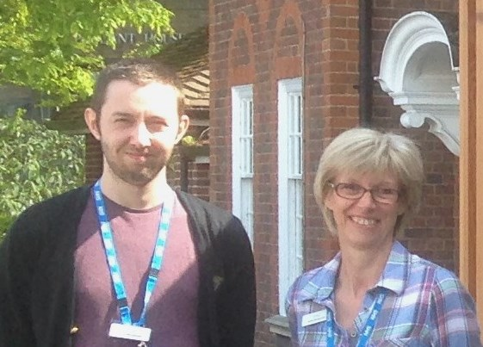  Practice Staff  We are pleased to say that our Reception team is now up to full strength again. Earlier this year we recruited Sally and Christopher (pictured above) at Huntingdon Road Surgery and Nandini at Girton Surgery. We have also appointed Portia as an additional secretary. We welcome them all to the team.  The only change in the Doctor and Nursing team is that Dr Towl will be going on Maternity leave and Dr Surabhi Singh will be joining us until Dr Towl returns in the New Year. We wish her all the best.  Older People’s Programme and Adult Community Services  The consultation on plans for Older People’s Healthcare and Adult community services continues throughout the Cambridgeshire and Peterborough area and parts of Herts and Northants until 5.00 pm 16th June .  Any patient in these areas is invited to take part so please make your friends and family members aware. It really is important that as many people as possible take part in this and share any ideas or comments they might have. If you think that some questions cannot be answered in a simple way then feel free just to write what your own thoughts are on a particular topic. Those planning the structure of | services do listen and amend plans if necessary and value patient input.  There are hard copies of the consultation document for you to complete in the surgeries and it is also available on line at www.cambridgeshireandpeterboroughccg.nhs.uk.  On the home page you will find OPP under Our Priorities. There is a Final Public Consultation on 7th June 10.00am until 12.00 midday at the Cambridge Central Library, Lion Yard or if you would like to phone to ask a question or have a consultation form sent to you, you can contact the Patient Experience team on 01223 725304.  Confidentiality  The practice is keen to maintain confidentiality for all patients and is aware that this can be particularly difficult in the reception area of Huntingdon Road surgery. Incoming phone calls are now taken in the closed office behind reception, unless there is a shortage of staff. Should patients wish to talk about sensitive issues, it is helpful to be aware that confidentiality and privacy can more easily be maintained by having a conversation over the phone rather than face-to-face at reception.  The practice is also planning to have a “Please wait here sign” in the reception area a short distance away from the desk so patients can have a little more privacy when talking to the receptionists. Patients can help each other by respecting this sign and by giving one another a little more space.  Patients are encouraged to use the Booking in Screen which is very easy to use and avoids the need to queue at reception.  Magazines are back!  Please help the PPG to re-stock the supply of magazines for use in the waiting rooms by leaving your surplus magazines and books for young children at Reception. PPG members will label them and try to maintain a reasonably up-to-date stock for all patients.

Survey Questionnaire  Thank you to all those people who completed our Annual Questionnaire last November and December. We had 228 responses with lots of very helpful comments and suggestions. We have carefully reviewed them with the Patient Participation Group, which has been an extremely valuable process. There were a number of clear themes within the responses, particularly the wish to have magazines and reading material in the waiting rooms again, which the PPG have kindly agreed to organise.  We have discussed all the survey responses and from these we have agreed an action plan to develop through the coming year:  - To continue to promote and increase the awareness of the Huntingdon Road Surgery Website, and to develop the Website as a means of explaining practice policies  - To look at ideas to improve the function of the reception area and waiting rooms at Huntingdon Road and Girton Surgeries  - To continue to increase the awareness of the Patient Participation Group and promote its role  - To help signpost patients to the most appropriate service for them to attend for their medical problem  - To continue to help inform people how health services are commissioned  The results of the Questionnaire are available on the Surgery Website with a full report. If you have any further comments or suggestions please do let us know either at the Surgery or through the Patient Participation Group. Thank you.  On line appointments available  We now offer online appointments. Please ask at reception if you would like further details. We will need to see ID to enable this.  Chaperones - a reminder  You may ask your doctor or nurse for another member of the medical or nursing team to be present if you are having an examination. There | is further information on the website. If you still have any questions, comments or suggestions, please speak to your doctor.  Sharing your health care information  It is now possible for information about your medical treatment to be shared with another healthcare provider who uses the same IT system (SystmOne) as the Huntingdon Road and Girton surgeries when they are also treating you. This can be particularly helpful in urgent situations and to keep your GP promptly up-to-date with care you may have received elsewhere. There are explanatory leaflets about this at reception in the surgeries and forms to complete if you wish to opt in to this scheme.  There is another and quite different national scheme proposed by the NHS to share information from health records and you may  have seen the leaflet 'Better information means better care' when it was delivered nationally a few months ago.  This programme will start in September 2014 and is for the purpose of healthcare planning, medical research and clinical audit. It is different from using information to support your care directly but in the long term could provide helpful information on a range of medical conditions. Individual patient's names are not shared. This is a scheme you would have to opt out of if you did not want your information shared. Again the opt out forms are available at reception. Further information is available at www.nhs.uk/caredata or on a patient information line 0300 456 3531  Information evenings  From time to time the PPG organises evenings open to all registered patients to provide information and guidance on a wide range of subjects from advice for carers to diabetes and a healthy diet. If you have any suggestions for topics that could usefully be covered, please let the PPG know by contacting us through the website or by leaving a note in the suggestion box which you will find in each surgery.

