The Patient Participation Group (PPG)  The PPG has just completed its first full year. We have worked to support the Practice in various ways such as arranging information events open to all Practice patients and publishing this regular newsletter. We also represent the patients' interests and listen to any suggestions, comments or concerns. In acting as a 'critical friend' we can discuss these with the Practice and many of your suggestions have been successfully followed up. We welcome new members to our group of about 80 patients; attendance at meetings is interesting but not essential and you can choose just to receive PPG information by email or post.  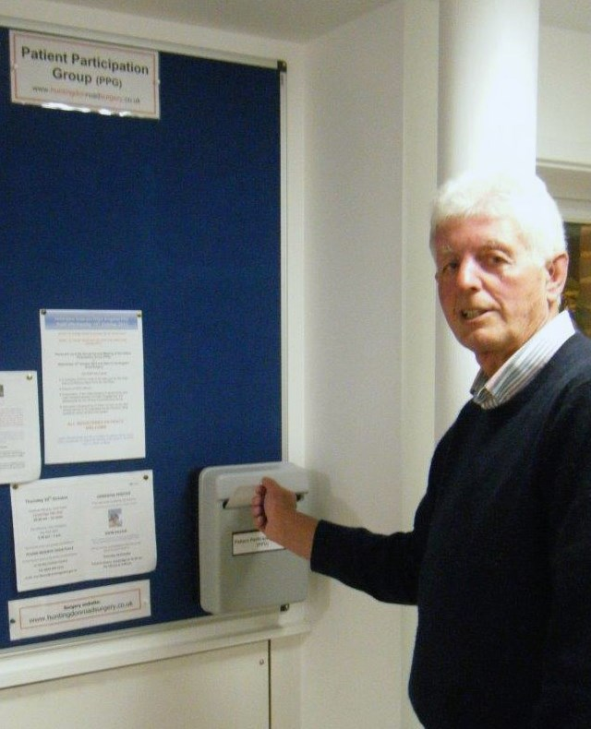  Contacting the PPG  You can contact us in two ways:  - through the HRS website by clicking on Patient Participation Group and then Contact Us  - by leaving your name and contact details in one of the new PPG post boxes in each surgery  We will always get back to you, however you contact us.  Carers’ Evening  The PPG and HRS staff recently held a successful evening event for carers. Those who  attended enjoyed presentations on the services | and support available plus the opportunity to hear about other carers’ experiences and talk about their own. They were also able to pick up useful information from Age UK and others. If you or someone you know is a carer and you would like some information on the services and support available to you please  - visit the practice website and click on ‘Are you a Carer?’ under the Patient Participation Group heading on the right hand side, or  - ask your doctor to refer you using a Prescription for Care  Patient Participation Group AGM  The second Annual General Meeting of the new Patient Participation Group (PPG) was held in mid-October. Speakers from the Clinical Commissioning Group spoke about changes planned for the delivery of care in the community and the Older Peoples Programme.  Magazines and toys  For reasons of infection control the practice has decided not to keep toys in the waiting rooms at the surgeries and has also decided not to keep magazines to avoid inappropriate material and untidiness. Some patients have expressed reservations and the Practice and PPG are continuing to discuss this. Patients are welcome to bring their own children’s toys or reading material in the future.  Getting to the Surgery  There is very limited parking available at the surgery in Huntingdon Road. The PPG has produced a new leaflet giving guidance on public transport to and from both surgeries and on street parking available in the area surrounding Huntingdon Road surgery for those who travel by car. Patients who are able to do so are encouraged to consider walking, cycling or using public transport to get to the surgeries – it’s the healthier choice!  Please ask at Reception if you would like a copy of the leaflet or post a request in the PPG box in either surgery.

Dr Byrne  We are delighted to welcome back Dr. Byrne following her absence on maternity leave  Safeguarding children  If you believe or suspect a child is suffering or likely to suffer significant harm, including any form of mistreatment or abuse, you should report your concerns.  For more information about safeguarding children and how to report your concerns contact the Local Safeguarding Children Board:  - Scott House, 5 George Street, Huntingdon, PE29 3AD, telephone: 01480 373522  - http:/www.cambslscb.org.uk/home_report.html  In an emergency, if a child is in immediate danger or left alone, you should contact the police or call an ambulance (call 999). The police operator will need to take your name, address and details of what has happened. This will take time, but it is important to get all the information from you so that the appropriate action can be taken  Annual Survey  We are also seeking your views more formally through our annual survey, which will be made available in the middle of November. You can | Complete an online version via the website  OR  - If you prefer a paper version, please ask for one at Reception and return it to the surgery when completed  All survey responses are anonymous, so we will not be able to respond directly to specific issues raised by individuals. However, all the surveys will be considered carefully with the PPG and the results of the surveys will be posted on the website in the New Year, together with any actions or changes planned. What you think is important, so please take the time to participate.  Flu Vaccine  Influenza vaccines are being offered again to help protect those patients who may be at greater risk of developing more serious complications. Flu vaccines are also being offered to children in the form of a nasal vaccine.  We would particularly recommend you have a vaccine if you have any of the following conditions:  - Chronic Respiratory complaints, including Asthma if you need regular steroid inhalers  - Chronic Liver or Kidney disease  - Heart Disease  - Diabetes  - Chronic Neurological conditions  And if you are:  - Immunosuppressed  - Pregnant  - Over the age of 65 years  - Children aged 2 and 3 years  If you are in one of these groups do go ahead and book an appointment to have a flu vaccine, unless you have had a serious reaction to a past vaccine, in which case you should first discuss it with your doctor or nurse.  The influenza vaccine program saves lives

